**Task No. 1:** Run the following commands on the command prompt of your PCs and attach.

snapshots of the result:

**Solution:**

1. ping www.google.com

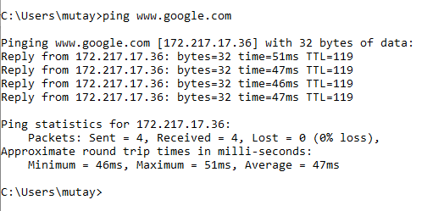

1. tracert [www.yahoo.com](http://www.yahoo.com)

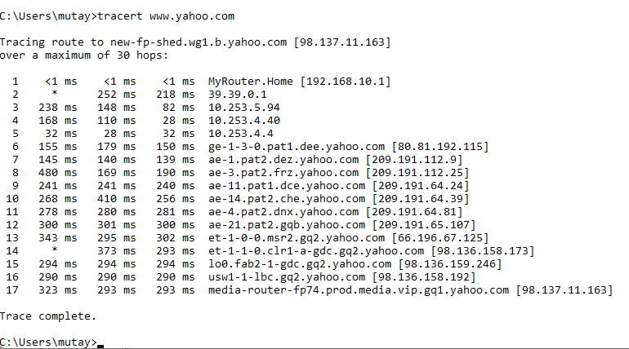

1. ping -i 6 www.facebook.com, did you receive the correct reply? If not, explain why.

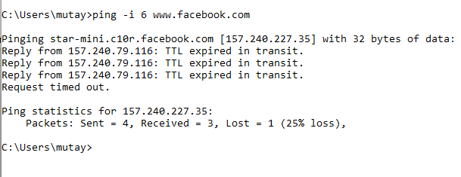

Time-to-live (TTL) has been reached: All IP datagrams have a time-to-live (TTL) field, which tells how many hops (i.e., routers) the datagram can pass from the transmitting computer to the receiving one. If a datagram is set with a TTL of 20, this means that if it doesn’t arrive at destination within 20 hops, the datagram should be discarded. This is done in order to prevent datagrams from being eternally circulating on your network or on the Internet if the network isn’t configured correctly and the datagram is walking around without any path to reach its destination.

1. A screenshot of a computer code

   Description automatically generatednslookup www.live.com, did you result show ‘Non-authoritative answer’? If yes, explain what does it indicate, you are advised to browse the internet to attain this answer



Non-authoritative answer simply means the answer is not fetched from the authoritative DNS server for the queried domain name.

**Task No. 2:** Differentiate between Ping and PathPing commands.

**Solution:**

**Ping**

Ping sends a single ICMP (Internet Control Message Protocol) echo request packet to a specified destination and waits for a response. It then displays the round-trip time (RTT) for the packet, which is the time it took for the packet to travel from the source to the destination and back.

Ping can also be used to determine if a destination is reachable and to measure packet loss.

**PathPing**

Pathping combines the functionality of ping and traceroute. It sends a series of ICMP (Internet Control Message Protocol) echo request packets to each hop along the path to the destination and displays the RTT and packet loss for each hop. This information can be used to identify which hop(s) are experiencing problems.

|  |  |  |
| --- | --- | --- |
| **Feature** | **Ping** | **Pathping** |
| Sends ICMP echo request packets | Yes | Yes |
| Displays round-trip time (RTT) | Yes | Yes |
| Displays packet loss | Yes | Yes |
| Traces the path to the destination | No | Yes |
| Identifies which hop(s) are experiencing problems | No | Yes |

**Task No. 3:** Find all Active/ Used IP addresses on your network.

**Solution:**

* By using ipconfig/all
* And arp –a

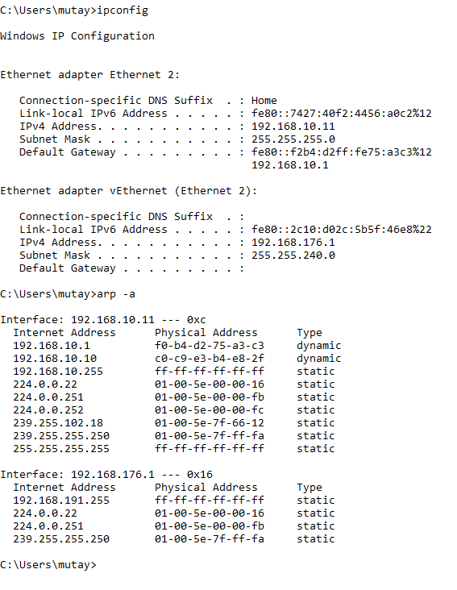

**Task No. 4:** How to verify connection with remote computer?

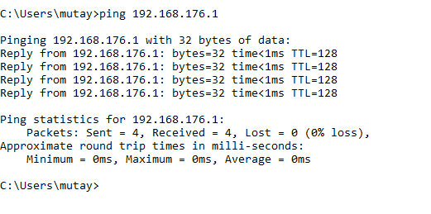**Solution:**

**Task No. 5:** Ping Parameters

1. 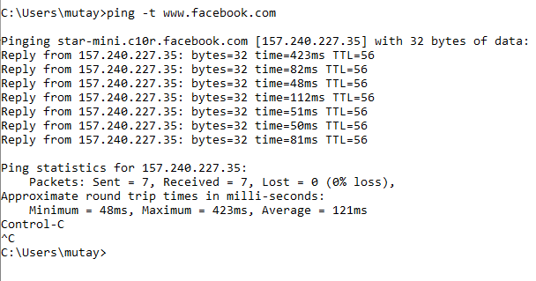**Ping -t**

1. **Ping -a**
2. A screenshot of a computer

   Description automatically generated**Ping -l 70**
3. **Ping -w**

1. **Ping -v tos**

